**Chapter 8-**

**Game Design Basics[1]**

Building a video game used to require a fair amount of technical expertise, but today’s technology has made it easier than ever. That said, having a good understanding of game design basics can make all the difference between an OK game, and a really great one. The following steps are basic considerations to help you get started with your game.

If you’re hoping to make a career out of games someday, consider taking a game design and [game development course](https://www.cgspectrum.com/game-development) to get a far more thorough understanding of the [game development process](https://www.cgspectrum.com/blog/game-development-process). You’ll learn how to build a game from scratch using the game design techniques used by major game studios, and feel more confident taking an initial concept through to testing and then to getting it on the market.

#### Steps To Building A Video Game

##### 1. Develop An Interesting Concept

The first step is to come up with an interesting and unique concept or idea for your game. You must also decide what style of game you wish to create (e.g. racing game, shooter, RPG etc.). You may also have some ideas about the storyline, special features, and the look or art style. All of these ideas should be recorded in one place - your game design document.

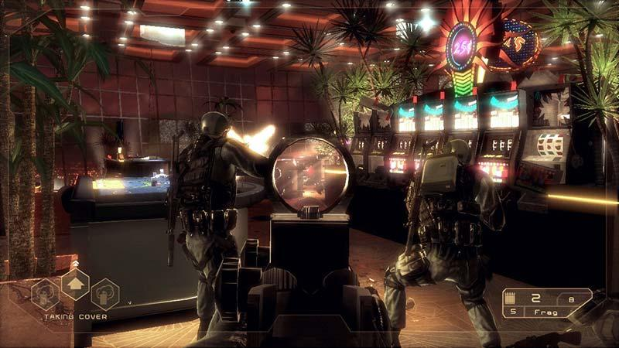While working on Tom Clancy's Rainbow Six Vegas at Ubisoft, Game Designer and CG Spectrum mentor Troy Dunniway collaborated with military advisers, studied special forces tactics, weapons, military uniform designs, special forces dialog and hand signals to add more realism to the game.

##### 2. Create a Game Design Document (GDD)

A Game Design Document is a living document which contains all of the most important aspects of your game. If you’re planning on building your game with friends or colleagues, the GDD helps everyone understand and get on board with the greater vision of your project. It’s also used to help pitch and finance your game (investors want to see a solid plan before investing).

Your Game Design Document should include:

* The idea or concept
* Genre
* Story and characters
* Core game mechanics
* Gameplay
* Level and world design
* Art and/or sketches
* Monetization strategy

A GDD helps keep you organized, can identify potential risks, and lets you see ahead of time who you may need to hire/outsource to in order to bring your project to life. Your game idea may seem fairly straightforward, but once you lay it out in a GDD, you might soon realize just how big and resource-heavy your project is.

##### 3. Get to Know Some Basic Game Design Principles

Having a solid understanding of basic game design principles will help you build a video game that is fun and engaging. As you put together your GDD, here are three main principles to keep in mind when designing your game:

* Stick To One Core Game Mechanic

To design a good game, try to focus on only one core game mechanic. A core game mechanic is an action the player will do repeatedly throughout the game.

Two examples of games and the core gameplay mechanic used are Pacman where players must eat all the dots to defeat the enemy; and Clash of Clans, where players are required to loot other clans to expand their empire.

A dull game mechanic will quickly lose your player’s interest. Study your favourite video games and see if you can spot the core game mechanics used.

* Make Your Game Easy to Understand

If you want your game to reach a wider audience, make sure it is easy to understand. Don’t assume your player has the same level of experience you do. Keep the rules simple and introduce them one at a time to help your players understand and learn them quickly. Make it easy enough for your players to learn new skills and techniques so they can successfully overcome the challenges you set for them.

Top Game Designer and creator of CG Spectrum's Game Design course, Troy Dunniway says: “If you throw too much at someone at once they’re not going to remember what to do. You can only remember a few things at a time. So we do what’s called ‘chunking’. Typically our memory remembers things better in smaller chunks... like how phones are segmented into three or four chunks of three to five numbers instead of just one long number. If we try to teach a player to run, jump, shoot, duck, learn a new story and recite the national anthem all at the same time, we overwhelm them. It’s a lot to process!"

* Introduce Prizes At Regular Intervals

Offer prizes to help motivate your players. Humans love appreciation and adding exclusive rewards throughout your levels can help motivate them to get to continue to the next level.

Professional Game Designer and CG Spectrum mentor Heath Smith says:

"As a Game Designer you’re not just designing for yourself, you’re designing for an audience. You have to get into the head of the player, understand what motivates them, what makes them tick, and design the game for them."

##### 4. Determine Software and Skills You Need

Larger game studios have teams of Game Designers and Game Programmers working together to build games (see the difference between a programmer and designer), but smaller studios may require staff to do a bit of everything. Same applies if you’re making a game on your own. Unless you have the budget to outsource (or friends who can help with the technical aspects of making a video game), you will need to learn to code and design.

Looking at your available resources and your own skillset will help you decide which software to use to build your game. Some game engines require more programming skills than others.

Many game engines are free until you start to make money off your game. If you want to make games professionally, try to learn industry-standard game engines that major studios are using, like Unreal Engine or Unity 3D.

Here are 5 free tools to check out:

* Unity 3D
* Unreal Engine 4
* GameMaker Studio 2
* Construct 3
* Godot Engine

It’s possible to create a simple game with basic coding skills. Graphic games require a deeper understanding of programming languages. If you’re planning on getting fancy, you may need to dedicate more time to learning how to code. Here are some of the most popular languages:

C++: This popular language is used to create advanced games like World of Warcraft and Counter-Strike. Most computer games are made with C languages. They can be difficult to learn but they offer greater control over your game. C++ is also commonly used by major game studios, so good to learn if you’re hoping to work for a big studio someday.

Java: This programming language is generally used with the Android Studio because it gives full control over customization. Java is not too complicated and you can get pretty good at it with practice.

JavaScript: JavaScript is the simplest language to learn and it can be used to make basic mobile games. It can be used in conjunction with JavaScript with other languages like CSS and HTML to create mobile games. It’s a low barrier to entry if you’re very new to game development.

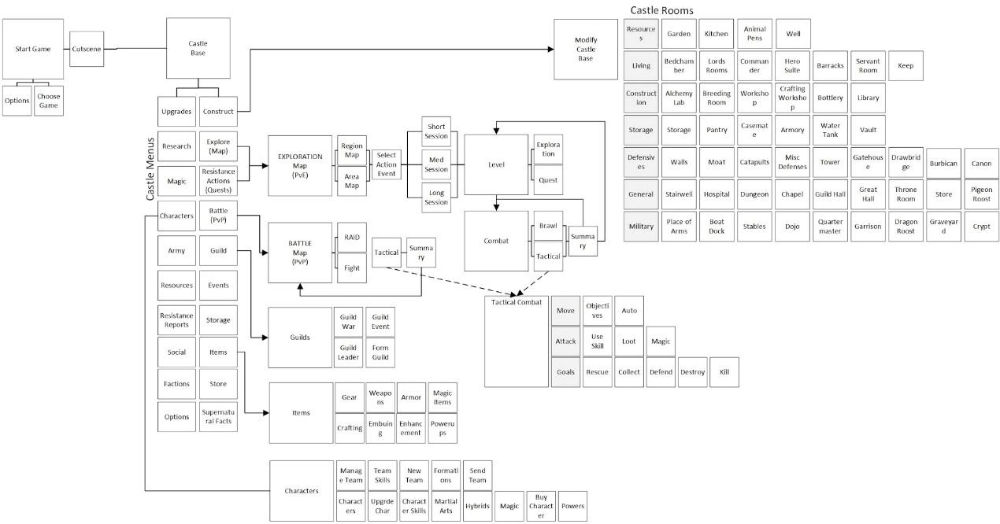Example of a user interface flow diagram for an unreleased RPG called Supernatural

##### 5. Start Building!

Here’s the fun part! Building your game will take a lot of trial and error, and you may discover that the things you initially thought were great ideas don’t actually work as well in reality. Be sure to get your friends and family to test your prototypes and listen to their feedback.

Remember, if you want to build a great video game for yourself, that is one thing. But if you are hoping to monetize your game, you need to think about your audience. What makes them tick? What motivates them? How do they like to learn? Incorporate this research and testing into your game design process, and you will have a much better chance of building a successful game!

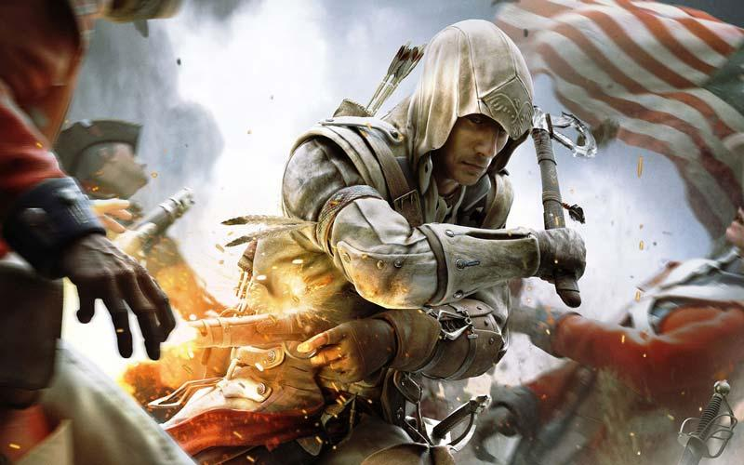Mentor Heath Smith suggests starting out small, especially if this is your first game: "You don’t need to start with the ultimate video game you’ve always dreamed of making. Start with something small and achievable."

#### Game Design Basics Summary

Building an engaging video game is no easy task. Fortunately, there are many platforms available to help you create games at home.

If you’re keen to build a solid foundation in game design be sure to check out our industry diplomas. There’s no faster way to learn game design basics than from an AAA game expert who will share actual case studies from best-selling games, and give you professional feedback on your game as you’re building it.

# Different Genres of Game[2]

All the games which we develop come under one of the various predefined categories, these categories are also called **Genre of Game**. Before developing a game, the game engineer or project leader has to decide what type of game he wants to develop for his audience. So in this chapter you will be learning about the types of games and their characteristics as well.

Genre of a game defines the exact category of the game and can be relayed through the similar gameplay characteristics, like - the type of objectives and storyline, the levels and camera point (i.e. FPS, TPS), the features and the storyline that the game is showcasing. Genre of a game is not defined by the content or the playing mode, but by the common challenges and characteristicss, that the game is having. For example, **FIFA** and **PES - Pro Evolution Soccer** have similar properties and objectives as both of them are soccer games and the player's get points or the levels of difficulty raises as the team wins the matches by scoring goals, like a real life football match. Genre of a game is decided by the resemblance found and listed under a common heading, here, FIFA and PES will come under *Sports-Genre Game*.

## Lists of all Game Genres

Here we have listed the main genres when it comes to categorising games.

### Game Genre: Action

The action category has some sub-categories and they are listed below:

* **Stealth Game:** These games lean towards emphasizing trick and precision in striking over the more obvious and unconcealed shooters. Examples are: Metal Gear series, IGI series etc.
* **Survival Games:** These games start with a minimal resource with the player, in a hostile condition, along with open world situation with the objective to collect resources, craft tools, artilleries and arms & protection, in order for the survival of the player as the game proceeds.
* **Shooter Games:** In these games, players draw on a range of weapons for contributing in the action that takes place at a distance.
* **Platform Games:** These games are set in three-dimensional (3D) environment where the player guides the character through the obstructions for advancement in game.

### Game Genre: Adventure

Just like adventure movies, games with the storyline of adventure are full of fictional landscapes, characters etc. These games portray a different way of gameplay without excessive reflex, hard core challenges or actions. The focus lies on the player in solving puzzles or mysteries by interacting with the environment. **Mario**, **Tin-Tin** are examples of adventure games. Some categories of adventure games are:

* **Graphic Adventures**
* **Visual Novels (based on novels and stories)** - Harry Potter (played using PlayStations, X Box and other gaming consoles)
* **Interactive Adventures (based on movies)** - Tin-Tin, Batman etc
* **Real-time 3D Adventures** - Shadow of Memories

### Game Genre: Role-Playing Games

In such games, a player is chosen who plays the major role in the storyline full of numerous **adventurers** and specializes in particular skill sets and that player progress in the storyline incrementing his skills and powers. This category is one of the most famous genres and is played by gamers worldwide. Here's a list of some sub-categories of role-playing games:

* **The roguelike Game:** It is a sub genre and its name comes from the gameplay elements of 1980 computer game **Rogue**. Nethack is another example of roguelike game.
* **Fantasy Games:** Games such as Diablo, Final Fantasy, Prince of Persia have a world full of unusual characters and villains and the player has to complete the levels full of challenges and mysteries and there lies some hidden routes which needs to be unlocked to proceed with the game.
* **Sandbox RPG (Open World RPG):** These are modern games where the player is given full freedom and can freely roam around and do anything (i.e. the player is not restricted to a single path by rocks & fences, single objective etc). Examples of such games are the famous **Grand Theft Auto (GTA)** series, **Watch Dogs Series** etc. These games provide a large geographic area to explore along with the primary objectives and tasks of the game.
* **Massively multiplayer online role-playing games (MMORPG):** This term came into existence commercially in the year 1990s and had existed since 1978. This involve more than hundreds of players interacting and cooperating with each other on the same platform in real-time.

### Game Genre: Simulation Games

These are primarily designed and developed to closely simulate(replicate) all the aspects of our real life or a fictional setup. The various sub-categories of simulation games are: -

* **Farming Simulation**
* **Vehicle Simulation**
* **Life Simulation**
* **Management Simulation**

### Game Genre: Strategy Games

Here the main focus lies on the gameplay which require a cautious and skilled mindset and a good plan for being victorious. In majority of the strategy games, Andrew Rollings, famous game engineer said that, **"the player is given a god-like vision of a game and the world exists with respect to it, and in some way controlling the units under his command."**

* **4X Game:** 4X games refer to a genre of a specific form of strategy video games having four primary goals which are-
  1. **eXplore**
  2. **eXpand**
  3. **eXploit**
  4. **eXterminate**
* **Real-time strategy (RTT) and War Games:** The real-time strategy games are characterized by acquiring resources, building bases and other assets within the game, and the player has to make specific decisions and perform certain actions constantly in order to cope up with the changing game state. For example: Age of Empires etc.
* **Tower Defence:** Tower defence games have a very simple format and gameplay. Make your tower strong by deploying suitable defene system to demolish the enemy troops.
* **Multiplayer Online Battle Arena (MOBA):** MOBA games are also called the **action real-time strategy (ARTS)** games, which is a sub-genre of strategy games which was originated as a real-time strategy game wherein a player takes control over a single character in one of two teams.

### Game Genre: Sports Games

These games emulate the gameplay of any traditional physical sports to be played on a device. The real-world sports like baseball, basketball, soccer, and more are available in the form of PC games. As you grow your skill levels, your game will also engage in mimicking real professional athletes and the way they move and play. Its sub-types are:

* **Racing**
* **Indoor Sports**
* **Outdoor Sports**
* **Fighting**
* **Competitive and Misc**

### Scientific and Educational Games

There are several cases where many parents and teachers complain about children playing video games, but there are a handful of great educational games out there which can actually help children and kids and even grown ups to learn new things and gather knowledge.

# Game Project Management and Business Context

Every game project, right from the massive multiplayer game's development having a budget of more than $6 million to small but interesting games (like candy crush), needs to be have a proper business plan.

In case, if you don't have a plan to make profits out of the game or if your game project is not linked to any business venture, there still lies a fine line for identifying - why you are developing the game and what are the goals set for the game's future, your planning. So it can be said that by all means, business side is also important.

## The Project Management Triangle

Project Management triangle is a helpful tool to analyze the aim and plan of any game project where the 3 vertices of the triangle stands for:

1. **Budget**
2. **Time**
3. **Scope**

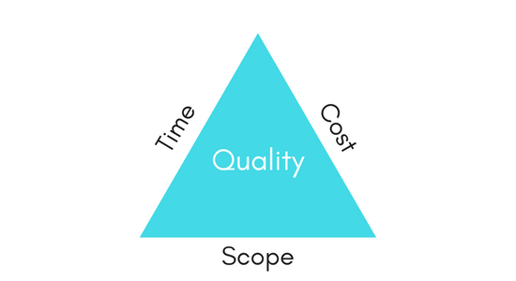

To get a good business plan in shape you will have to follow some project management procedures to define the requirements of the project along with various other aspects.

Project Management Triangle is one such model, which allows Project Managers to forecast how the project development steps will fair in terms of quality, based on budget, time and scope factors.

It helps the project managers to understand the difficulties that may arise during the game project development beforehand during the planning phase, and hence makes the project management better.

There is a business law in software development and/or game development industry which states that your project can achieve any 2 out of the 3 goals for a project, but there is no way to achieve all the three of them together.

There are some project developers who fail to understand the fact that only two out of the three project triangle properties can be possible at a time, which results in projects missing out on all 3 of these goals! So, we have to keep in mind the fact that we must work towards making our game better in any two of the specified triangle properties and take the third one to a moderately good level.

## The 3 Constraints

1. **Budget**:

Every project has a cost attached to it, and its important that the project is completed within the set budget. Some times due to poor project management in the initial development phase, it becomes difficult to finish the project on time. In such cases, extra resources(more developers) are hired to work on the project, which adds to the project cost/budget.

1. **Time**:

When we work on a project, time plays a very crucial role as deadlines must be met. If project completion is delayed, it directly affects(increases) the budget of the project.

1. **Scope**:

Scope of any project is pre-decided in the requirements and planning phase. The project team know about the deliverables of the project before the development phase starts and must finish them within the set deadline. On the other hand, Project Managers must have the capability to handle any change in the requirements/scope which affects time and cost.

### Quality

Quality is not one of the three constraints of the project management triangle but it is the ultimate goal. Afterall, every team desires to produce best quality product. Some confuses, quality with cost, stating that, only high cost can lead to high quality product. Which is true to some extent, as without good resources, the overall project can never be successful.

### Using Project Triangle

The three sides of the project triangle are represented by one of the three constraints. It has been found by conducting studies and experiments on live projects that it is very rare that a project abides by all the 3 constraints, which means, the project is finished on time, within a set budget and all the deliverables of the project are completed.

In real life, if a project development initiative, assures of achieving deadlines in terms of **time** and **cost**, then it will miss out on the **scope** of the project. Similarly, if a project has to be completed within a set **budget** with complete **scope** then it will take more **time** than decided. And lastly, if you believe in the saying *"Time is Money"* and wish to finish the development before the **time** deadline with complete **scope**, then you will have to put in more resources, which will affect the **cost**.

A developer may follow one of the many different application development strategies on the market like *Waterfall*, *Spiral Model*, *Iterative* etc. But none of the listed development techniques and models will magically solve all the problems. You will sooner or later during the project development phase, face the question of how to efficiently manage your project with respect to the business model and the three constraints. The possible outcomes while following the Project Triangle can be:

* **On Budget and On Time:** means you must accept sacrifice of quality
* **High Quality and On Budget:** means you must accept a late game
* **High Quality and On Time:** means you must accept extra spending

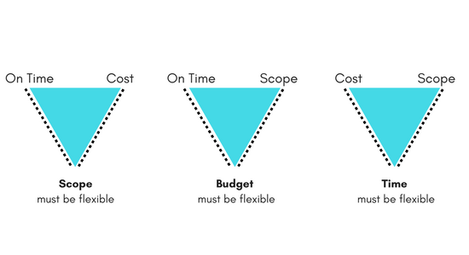

# Best Game Engines of 2021[3]

hen it comes to game development, choosing the right game engine for your game can make or break the entire experience.  There are also a lot of factors to consider:

* What kind of game are you trying to make?
* Is your game 2D or 3D?
* How experienced are you?
* How vibrant is the engine or framework’s community?
* What sorts of resources are available for the engine?

With all these factors to consider, it can be a real challenge to make sure you pick the right foundation to work from.  This is especially true in today’s age where technology evolves constantly, meaning new engines and updates are coming out all the time with novel innovations.

To make the choice just a slight bit simpler, though, we’ve compiled a list of the best game engines in 2021, along with the strengths and weaknesses of each engine based on some of the factors mentioned, to help you along with the process.

Before jumping in, we recommend reading our [How to Code a Game](https://coding.degree/how-to-code-a-game/) and [How to Make a Game](https://gamedevacademy.org/how-to-make-a-game/) articles if this is your first introduction to game development, as these will help you takes your first steps before jumping straight into picking an engine. You may also like our [Best Programming Languages to Learn to Code article](https://coding.degree/best-coding-languages/) as a way to narrow down your language preference!

Table of contents

* [Unity](https://gamedevacademy.org/best-game-engines/#Unity)
* [Unreal Engine](https://gamedevacademy.org/best-game-engines/#Unreal_Engine)
* [Godot](https://gamedevacademy.org/best-game-engines/#Godot)
* [Phaser](https://gamedevacademy.org/best-game-engines/#Phaser)
* [GameMaker Studio 2](https://gamedevacademy.org/best-game-engines/#GameMaker_Studio_2)
* [Conclusion](https://gamedevacademy.org/best-game-engines/#Conclusion)

### [Unity](https://unity.com/) Unity Editor overview

Having been developed since 2005, the [Unity game engine](https://unity.com/) has become a staple of the indie game industry.  With constant updates and new, major features, such as Unity Reflect, being added every year, the support for the engine is unbelievable.  The engine is not only well-suited for both 2D and 3D games of any type, but it is also a popular choice for VR and AR development as well thanks to many companies and developers creating convenient SDKs for the engine.  Beyond this, Unity also has a sizeable community, with an active [Asset Store](https://assetstore.unity.com/) with both free and pay-to-use assets at your fingertips.  As it’s such a robust engine and free for developers earning less than $100K/year, it is a fantastic choice for beginners regardless of what they want to make.

This being said, if you are looking to develop an entire game studio around Unity, the licenses can be costly – though they do come with more features.  Additionally, Unity can be heavier on your system if you’re running some of the higher-end tech demos to bring out the full capabilities of the engine.  Lastly, it’s worth mentioning that as Unity updates so often, it can be easy to miss new features or be a struggle to find old ones as the UI and system for accessing them might change.

Below you can check out a short film created with the Unity engine using Unity’s [High Definition Rendering Pipeline](https://docs.unity3d.com/Packages/com.unity.render-pipelines.high-definition@8.1/manual/index.html) to see the full capabilities of the engine.

**Strengths:**

* Free for beginners earning less than $100K
* Great for 2D and 3D games
* Strong mobile game support
* VR and AR SDK availability
* Asset Store with tons of free assets

**Weaknesses:**

* Costly licenses for professionals
* Higher-end tech demos require better computers
* Many UI changes

**Examples of Games Made with Unity**

* [Osiris: New Dawn](https://unity.com/madewith/osiris-new-dawn)
* [Hollow Knight](https://unity.com/madewith/hollow-knight)
* [Rick and Morty: Virtual Rick-ality](https://unity.com/madewith/rick-and-morty-virtual-rick-ality)
* [Genshin Impact](https://genshin.mihoyo.com/en)

Is Unity for you?  Check out some [Unity courses](https://academy.zenva.com/product/unity-game-development-mini-degree/?zva_src=gamedevacademy-bestgameengines) created by Certified Unity Developers to get started! You can also review the free [Unity tutorials](https://gamedevacademy.org/category/unity-tutorials/) on this blog. We also recommend you check out our [Unity vs. Unreal Engine article](https://gamedevacademy.org/unity-vs-unreal/) if your choice is narrowed down between those engines!

### [Unreal Engine](https://www.unrealengine.com/en-US/)



Due to its robust graphical capabilities with lighting, shaders, and more, [Unreal Engine](https://www.unrealengine.com/en-US/) is the power-house behind many of the most popular, triple-A games out there today.  Given its rampant use in that sector, the engine has been developed very specifically to handle a lot of complicated tasks more efficiently than other engines.  Like others on this list, the engine is also open-source, meaning the community is constantly improving the engine as well.  Along with its [visual blueprinting](https://docs.unrealengine.com/en-US/Engine/Blueprints/index.html) so even non-programmers can develop their games, Unreal truly is a power-house that is capable of just about anything – including VR.  Did we also mention that, like Unity, there is also a [Marketplace](https://www.unrealengine.com/marketplace/en-US/store) where you can get free assets?

However, many developers do report that Unreal Engine is better suited for larger projects and projects you intend to work on as a team.  Additionally, as the program is heavy on the graphics end, many people will find it requires a more powerful computer compared to other engines like Unity.  Beyond this, it is also noteworthy that while Unreal Engine can create 2D games in addition to 3D games, the engine is not necessarily the best suited for the task.

The video below represents just some of the amazing things students around the world have created with Unreal Engine.

**Strengths:**

* Great for high-end graphics
* More performant than other engines
* A top choice for VR
* Visual blueprinting for non-programmers
* Sizeable marketplace with free assets

**Weaknesses:**

* Not the best for simple or solo projects
* High-end graphics require more powerful computers
* Better for 3D than 2D games

**Examples of Games Made with Unreal Engine**

* [Soulcalibur VI](https://www.unrealengine.com/en-US/spotlights/unreal-engine-spotlight---bandai-namco-entertainment)
* [Gears 5](https://www.unrealengine.com/en-US/developer-interviews/the-coalition-dives-deep-into-the-tech-of-gears-5)
* [Dragon Quest XI](https://www.unrealengine.com/en-US/spotlights/how-dragon-quest-xi-came-to-life-with-unreal-engine-4)

If Unreal Engine sounds like the engine for you, check out [these courses](https://academy.zenva.com/product/unreal-game-development-mini-degree/?zva_src=gamedevacademy-bestgameengines) to get started with your Unreal game development projects! Alternatively, you can check out some of our [free tutorials](https://gamedevacademy.org/category/unreal-engine-tutorials/), or even review our [Unity vs. Unreal Engine](https://gamedevacademy.org/unity-vs-unreal/) article (if you haven’t done so already) to get more information.

### [Godot](https://godotengine.org/)



Even though [Godot](https://godotengine.org/) has been around since 2014, it’s only recently that the engine has truly picked up in popularity.  The Godot game engine is fantastic if you’re looking for something free and open-source, meaning you can alter the engine and sell your games however you would like.  The engine supports both 2D and 3D capabilities, so it is well-rounded for any sort of game you’re trying to make.  Godot also takes a unique approach with its [node](https://docs.godotengine.org/en/stable/classes/class_node.html?highlight=node) and [scene architecture](https://docs.godotengine.org/en/stable/getting_started/workflow/best_practices/scene_organization.html) to represent specific game functions, setting it apart from similar competitors and which may be easier for many users.  Add a passionate community surrounding the engine, and you’ve got a real winner on your hands!

As for weaknesses, Godot does use its own personal language for scripting, called [GDScript](https://docs.godotengine.org/en/stable/classes/class_gdscript.html?highlight=gdscript).  While the language works fantastically and is reminiscent of Python (a favorite language for many developers), as it was specifically designed for Godot, experienced developers may consider it tedious to adapt to yet another language.  Additionally, as Godot is not as well known as some other engines here, there aren’t as many resources available compared to a staple engine like Unity or Unreal.

Looking for examples?  Below is a showcase of just some of the games being made for mobile using the Godot game engine!

**Strengths:**

* Works for 2D and 3D games
* Free and open-source – even commercially
* Passionate community
* Unique architecture for game development

**Weaknesses:**

* Experienced developers may not like GDScript
* Not as many resources as other engines

**Examples of Games Made with Godot**

* [ProtoCorgi](https://kemonogames.com/)
* [Deep Sixed](https://www.littlereddoggames.com/deep-sixed)
* [Gun-Toting Cats](https://kit9studio.itch.io/gun-toting-cats)

If you’re interested in this open-source engine, we recommend checking out the following [courses](https://academy.zenva.com/product/godot-game-development-mini-degree/?zva_src=gamedevacademy-bestgameengines) to get you started with your learning! You can also read some [free tutorials](https://godottutorials.pro/) if that is more your fancy.

### [Phaser](http://phaser.io/)



[Phaser](http://phaser.io/) began its life around 2013, though the most recent version, Phaser 3, has only been around since 2018.  Even so, this hasn’t stopped the framework from being extremely popular, especially for those who want to make mobile or browser-based games.  As the technology behind Phaser is largely based on the same technologies used for web development, it is also a framework that is relatively stable even as different versions come out.  Beyond this, Phaser comes with physics and the other sorts of additions any engine is expected to have, meaning you can make any number of games with it – including MMORPGs – with the right additions!

Overall, though, Phaser is a 2D based framework, so it may not be the best suited if you’re trying to make a 3D game.  Additionally, while the framework is cross-platform, as it is mostly geared for browsers, it comes with some limitations that more powerful, stand-alone engines don’t have.

Below are some examples of various games made with Phaser, links to which you can find in the examples below!



**Strengths:**

* Great for browser and mobile games
* Extremely stable
* Easily expanded with web technologies

**Weaknesses:**

* Geared specifically for 2D games
* More limited than other engines

**Examples of Games Made with Phaser**

* [Magikmon](http://phaser.io/news/2019/06/magikmon)
* [Gems ‘n Ropes](http://phaser.io/news/2020/03/gems-n-ropes)
* [Pickem’s Tiny Adventure](http://phaser.io/news/2020/04/pickems-tiny-adventure)

If you’re ready to expand your HTML5 game development skills with Phaser, check out these [courses](https://academy.zenva.com/product/html5-game-phaser-mini-degree/?zva_src=gamedevacademy-bestgameengines)! Alternatively, you might also like the free tutorials available [here](https://gamedevacademy.org/category/phaser-tutorials/) and [here](https://phasertutorials.com/).

### [GameMaker Studio 2](https://www.yoyogames.com/gamemaker)



This popular game engine created in 2017 is the newest version of [GameMaker Studio](https://www.yoyogames.com/gamemaker), which has been around since 1999 through many iterations and names.  GameMaker is widely supported across multiple platforms, even including the Nintendo Switch.  It is also a very friendly choice for those who have no experience with coding, as it primarily uses a [drag-and-drop visual scripting](https://docs2.yoyogames.com/) language of its own creation to allow all skill levels of users to create their dream games.  For those who prefer coding, though, it also offers its GameMaker Language to program custom behaviors that extend beyond what the visual programming can cover.  Overall, the engine is very beginner-friendly and opens up game development to just about everyone.

Unlike many of the other engines and frameworks on this list, though, GameMaker Studio 2 is proprietary, so it may not be a great choice for those looking for something on a budget.  Additionally, like Phaser, this engine is geared specifically for 2D games.  While it does have limited 3D capabilities, it is nowhere near anything like Unity, Unreal, or Godot can do.

Check out the showcase below of games made with GameMaker Studio!

**Strengths:**

* Supported on tons of platforms
* Easy drag-and-drop programming
* Extremely beginner-friendly

**Weaknesses:**

* Oriented more for 2D games
* Costs money to obtain

**Examples of Games Made with GameMaker Studio 2**

* [Hyper Light Drifter](https://www.yoyogames.com/showcase/13/hyper-light-drifter)
* [UNDERTALE](https://www.yoyogames.com/showcase/102/undertale)
* [Forager](https://www.yoyogames.com/showcase/231/forager)

# How to Design a Game: Game Design Documents[4]

So, you’ve got your brilliant video game idea that you just can’t wait to turn into an actual game and get into the game development process. You start searching around on the internet (something you will likely continue to do) and maybe you come across a tutorial about [How to Make a Game](https://gamedevacademy.org/how-to-make-a-game/). In it, you notice this section on “**game design**” and a reference to this thing called a “Game Design Document” (or GDD).

If you do a bit more searching, you’ll find other game developers and designers frequently mention “Game Design Documents” when they talk about the projects they’ve created. Given the number of times a Game Design Document is talked about, you might start to think that a Game Design Document is pretty important when designing a video game. However, most of these mentions fail to answer three questions: “What even is a Game Design Document, how do I make one, and why does it matter to game design and becoming a game designer?”

If you’re asking yourself these questions, I have good news for you! You’re not only starting your project in the best way possible, but you’re also in the right place when it comes to answering those game design questions, especially concerning Game Design Documents.

This tutorial is my “Magna Carta” of game design for all game developers out there. Throughout, we’re going to be taking that game concept in your head and work through designing it via a Game Design Document. We’re going to be taking the raw ore of your game concept and putting it on the anvil to hammer out its form (borrowing a figure from the world of metalworking). A Game Design Document is, in my opinion, the biggest step you will take to making your dream video game come true and becoming a game designer.

And so, with all that said, let’s get into the specifics of what a Game Design Document ***is***and what it is ***not.***



### All About the Game Design Document

#### What is a Game Design Document?

I can give you the material and formal definitions of a Game Design Document. What a Game Design Document is physically is usually a document consisting of your video game’s description. What it *could*look like is a 3-ring binder with 20 or so pages, *or*it could just be 8-10 pages in a spiral notebook. The physical characteristics (i.e. number of pages, page length, even page size) will be different for different projects, since the focus here is the game design itself.

What will not be different is the “formal” characteristics of a Game Design Document (i.e. What Game Design Documents are meant to communicate). A Game Design Document is supposed to communicate the “big ideas” of your game. What the essence of your game is. One way of thinking about it is, “What sets your video game apart?” It is important to think this way for two reasons, the first is it encourages you to be unique and creative. If you have an idea for a game and you just think, “Well it’s going to be exactly like Mario Brothers,” then you probably should think about it more. Players are not going to like exact copies of another video game. There are some exceptions to that statement but as a general rule, it’s accurate.

Secondly, thinking like this will help you determine what you should put in your Game Design Document. Answering, “What is unique about my video game?” will help you figure out what characteristics you should emphasize or what you can leave out. When I first started making games and exploring video game design, I quickly realized that projects with a Game Design Document tended to be more polished than ones where I just jumped straight into coding – showing me the value of taking time with the game design.

#### What a Game Design Document *does* cover

So that’s what a Game Design Document *is,* but let’s get more specific than that. What *specifically* does a Game Design Document Cover? The best Game Design Documents answer these four questions for the game designer and team:

1. What is/are the game mechanics?
2. Who is the player?
3. What is the story/point?
4. What will it look like?

If you can answer these questions and compile them into a single document, you will be well on your way to making your video game a reality and becoming a game designer. Also, please note that this is a list, not an order. The order in which the answers to these questions appear in your Game Design Document is something you can decide once you’ve already thought it through. However, I would encourage you to think about it in this order for reasons we’ll get to later.

But having seen what a Game Design Document *is* about for a game designer, let’s look at what it is *not* about.

#### What a Game Design Document *does not*cover

This is almost as important as knowing what it does cover. If you continue to make games (as I sure hope you will), you’ll likely have family or friends “pitch” you an idea for a video game design. Usually, they will tell you their idea without having thought about it from the perspective of a game developer. I’ve had friends tell me about their game concept and then launch into a long and detailed explanation of the game’s story or a description of what the player will look like. This is important to think about but it’s not going to help you draft a Game Design Document or make it anything more than just an idea. Therefore, let’s look at what a Game Design Document is *not.*

* A Game Design Document is not an exhaustive story or “script”

A Game Design Document is not a place where you do your world-building. This should be a separate document for two reasons. The first is that this is usually very long and needs to be written much like a movie script. While it is a good idea to include your game’s complete storyline, the exhaustive story should be done separately. You are writing a Game Design Document, not a novel. Therefore, it’s important to only include the portions of the story that affect the game design itself.

Secondly, the game’s complex story, with all its intricacies and backstories, is not the big question you need to answer at the moment. If you’re going for a video game design with expansive lore, then there will be a time when the story should be described in detail. But when it comes to drafting a Game Design Document, the focus is the other things about your game that will make it fun. In fact, as a game designer, you may not even be involved in all aspects of the story!

* A Game Design Document is not set in stone

Do not worry about getting everything right first go. Feel free to modify and change this thing if you feel it is necessary. In fact, it’s bad practice to not have some sort of fluidity attached to your Game Design Document. Lots of things happen during development that can necessitate a change in your Game Design Document.

* A Game Design Document should not contain entire programming scripts

This one is a bit obvious but it’s important for programming nerds (like myself) to understand. Don’t copy-paste a script into the Game Design Document. Leave it in your proof of concept, it’s fine there.

Now that we’ve seen what a Game Design Document is in broad strokes, let’s get into the details about your game’s design and how you can put that into your Game Design Document and become a true game designer.



### What are the Mechanics?

By putting this first, I’m deviating a bit from conventional game design wisdom. Most Game Design Document guides say to include other things like characters or story elements first. But I’ve found as a game designer that thinking about the game mechanics first is extremely important for one big reason, it answers the two important questions, “Is this even possible, and is this even fun?”

Maybe I’m a bit biased but I am a huge fan of games that have one incredibly interesting mechanic rather than a deep and moving story. Memorable game mechanics are one of the reasons we’re still playing games like Asteroids, Pac-man, and even Pong.



This is why I think it is important, especially for indie game developers and game designers who don’t have a lot of resources at their disposal, to consider the integral mechanics going into your game.

Here’s an example from one of my projects. I had this idea for a 2D platformer where the only way you could kill enemies was by picking up a block and throwing it to deal damage. No weapons, no magical powers, just this block, and a throwing ability. The player could also manipulate some physics and do a couple of other things but that was the main idea.

Now, on paper, it sounds like a great idea. Whenever I would talk to people about it, they’d say, “That sounds awesome!” I had an idea for a core mechanic and it sounded interesting. But when I created a prototype of the mechanic, it was obvious this would kill the video game. It was slow, clunky, and not an ideal combat system in any respect. By thinking about mechanics first, I was able to determine that, yes, this was possible but that it also wasn’t extremely fun. Thus is the process of being a game designer!



With that said, let’s get into the nitty-gritty of the “Mechanics” section of your Game Design Document.

#### What even are “mechanics”?

This is an excellent question we need to think about before we can start doing anything with our video game. The textbook definition of game mechanics is that they are: ” [a] construct of methods or rules designed for the player to interact with” [[Beginners Guide to Game Mechanics](https://www.gamedesigning.org/learn/basic-game-mechanics/), gamedesigning.org]. An example would be the “shooting” mechanic in Asteroids and the way the asteroids break up. The player presses a key and the space ship shoots (this is the *method*). A large asteroid breaks up into smaller asteroids when shot (this is the *rule*).

A mechanic can be as simple as “Press E to open the door” or it can be as complicated as a crafting tree (like in Minecraft or Terraria). Another way of thinking about it is “how does the player accomplish the game objective?” If you answered, “By killing enemies in the dungeon”, that’s your mechanic. If you answered, “by swimming around to find resources to craft items,” that’s your mechanic (two mechanics in that case; swimming and crafting).



This way, projects that are heavily mechanics focused will have a Game Design Document developed in areas where it matters most (i.e. the mechanic’s section). If a project is more story-focused, then the mechanic’s portion of the Game Design Document can be completed relatively quickly. Remember, game design isn’t an exact process.

#### Coming up with a “proof of concept”

This is basically where you build a prototype of your mechanic. I use the term “proof of concept” in its most general sense. For mechanics in your game, you need a “proof” that this “concept” will work. This is especially important if the mechanic is unique or new. In fact, only do a proof of concept for mechanics that need it. You don’t need to spend time working on a health bar mechanic if all that the health bar does is increase or decrease. You don’t need to prove that “Press E to open the door” is possible. Keep your efforts in this section to the most difficult and obfuscated mechanics your game needs. Also, please do not make it complicated when it comes to graphics or setup. My 2D platformer looked like this in its prototyping stage:



It should be so simple that you can sit someone down, hit play, and say, “This is what our combat system will be like,” or “This is how the player is going to swim,” or “This is how the player can craft items.” The point of this section is to make the programming part of your game development quicker. If you can do the hard work of coming up with your mechanics, you can focus on the other parts of the video game when it comes to full-on production.

#### Talking about mechanics in your Game Design Document

So you’ve created your “proof of concept” and you conclude, after testing it thoroughly, that this is indeed what your game needs and you like your game design. Or let’s even say that your game has some simpler mechanics like door-opening or dynamic day-night cycles (I guess the latter can vary in simplicity), how should you put this in your Game Design Document? As always in a Game Design Document, formats are fluid rather than rigid but a general format should look something like this:

1. A Quick Description of the Mechanic [e.g. “Blocks can be picked up and thrown to deal damage”]
2. A Quick Description of how it’s going to be implemented [e.g. “The player uses this to defeat enemies”]
3. A way to access your proof of concept

The third step is important if you’ve got a team of people working on it with you – especially if you’re the main game designer. If you’re working on a digital Game Design Document (like a Google Doc or slide presentation), then you can simply add a link to a Github or a Google Drive. The specifics of how you do this isn’t important. The important part of this entire section is that you know what mechanics are going into your game. Having this nailed down will help you in answering the next question of this game design process.

### Who is the player?



Since I’ve stressed the mechanics part of your game design and Game Design Documents, we need to jump to the next logical step and talk about how those mechanics affect your player. What is the player going to be doing in your game? This is where you can talk about the story, placement, and characteristics the player has. You can do this in whatever format makes sense for your project. Usually, a short paragraph makes the most sense. An example from a survival game would be something like this:

*“The player is a scientist who crash-landed on a watery planet. The player must swim around the environment to locate resources necessary for survival and escape. The player must also fend off hostile aquatic aliens if they hope to survive. By crafting items, the player can build vehicles, tools, and housing.”*

This will give some helpful context to your player.  Please note that while we are talking about the story, we aren’t laying it out fully at the moment. We just need to highlight some portions of the story to better describe the player. The full story progression will be addressed later on in this tutorial. This short description will serve as a sort of introduction to the other things about the player. First of which being the abilities required of the player when they play your game.

#### What are the player’s abilities?

We need a list of all the abilities the player has. As close to comprehensive as possible. Going back to our example from the survival game, a list of abilities might look like this:

* Swimming with WASD and mouselook
* Item pickup
* Inventory management
* Item crafting
* Object scanning

By hitting as many points as possible, it goes into much more depth than the description we wrote earlier. And there are two reasons this is important. The first is that it will tell you what level of proficiency is required to play your game, which in turn informs your target audience a bit. Given the above example, I’d say only very young children wouldn’t be able to play this game (i.e. it has a broad possible target audience). The second reason is it will reveal whether or not there is a possibility for imbalance. Imbalance usually crops up when the player has the ability to make a wide range of choices either from characters or items. And it just so happens that imbalance is the topic we’re going to talk about next.

#### Balancing your game



Balancing a game is a huge topic so we’re obviously not going to cover everything in this short little section (it is also a very difficult part of being a game designer). However, there are some important guidelines we can look at when it comes to writing your Game Design Document.

First off, realize that certain genres require more balance. By looking at our player description and realizing what sort of genre that falls into (i.e. survival games), we can determine that most of the balancing will take place in level creation.

Secondly, realize that balancing a game can be an ongoing chore rather than a one-time event in your game development. In a survival game, you as the dev and game designer have the ability to tweak everything until it’s perfectly balanced. However, for online games with many players (the most obvious example being online shooter games), balancing is going to be a bit more nuanced. If you play *Counter-Strike: Global Offensive*, you’re likely familiar with all the balancing the devs and game designers have done throughout the game’s history. In fact, most of these guidelines are going to be targeted for that sort of game genre. So let’s have a look at how we might improve the balance of that sort of game.

#### #1 Look for complementation not cancelation

If you’re the dev or game designer of a shooter game and you notice that one gun has four-times more kills than any others, your immediate reaction might be to tweak some parameters on that gun to make it less powerful. This may be necessary for some situations but as a general rule, it’s much better to tweak another weapon to match the strength of that weapon.

For example, if the over-powered gun is a shotgun that instantly kills when close to the enemy, you might consider giving a bit more strength to the sniper rifles that work better with long distances. This is a more ideal situation that leaves players saying, “The shotgun is good for some situations and the sniper is good for others.” The technical terms are “nerfing” and “buffing” and what I’m encouraging is to buff rather than nerf. Obviously, this is a guideline and not a rule.

There are situations when it is better to nerf. The Counter-Strike devs decided to nerf the SG 556 (also known as the “Krieg”) in April of 2020 because it was quite obviously overpowered. However, they didn’t nerf it to be equal, rather, they nerfed it on only a few parameters (like fire rate and short-range accuracy) while buffing another gun on the opposing team (the Counter-Terrorist AUG). This shows that complementation is still much better than cancelation and buffing is better than nerfing.

#### #2 Use math and then don’t

When approaching a balancing problem, it might be tempting to come up with some sort of mathematical formula that guarantees a balanced game – making your life as a game designer easier. This is a good idea when you’re drafting your Game Design Document to have some sort of idea as to how you’re going to balance your game. If you write out your player’s abilities and find that your player can pick from a catalog of weapons or characters, you’re going to need to know how to balance everything.

But the danger of this is that your game-play isn’t fun anymore. A set of characters or items may be mathematically balanced, but that can take the fun out of a game. Rob Pardo, the former Chief Creative Officer at Blizzard Entertainment, talked about the effects “mathing everything” can have on your game:

“..often times […] I have more junior deisgners that are more analytical and very math based [who] get very scared of too powerful abilities or too powerful of units. And they want to spread sheet everything down and they want to do a nuanced kind of balance. ‘What if we just increase their damage by one or increase their damage by two?’ Well why don’t you just increase it by 10 and then look at [the opposite team and see] about increasing their armor by more?…Celebrate the big differences between units because otherwise you’re going to end up with an army game […] where everything kinda feels the same…and you can high five each other and say it’s balanced but is it fun? Probably not.” (“Making a Standard: Blizzard Design Philosophies”, [GDC 2010](https://www.youtube.com/watch?v=FhC0NaB6ock))

In other words, a mathematically balanced game isn’t as important as a fun game. So keep this in mind as a game designer.

### What is the story?



Now that you’ve got a good idea of what the player is supposed to be, you are ready to place the player into the larger narrative. Here is where your bright fantasy world or cold survival story comes to life. Keep in mind who is going to be reading your Game Design Document. Other game developers or artists are going to be reading it. This means you don’t have to write a novel but more like a synopsis. It should contain details about the setting, theme, and actors in your game. The exact format is, as with everything in the Game Design Document, not as important as getting the information from your head onto paper.

Also, please note that this section is one that can and should be expanded and changed. Story-telling is complicated and so don’t worry about writing a triple-A story the first go. In fact, please take your time with this section especially if your game is story focused. That being said, here are some helpful tips to guide you along as you think about crafting your game’s narrative.

#### Who are the actors?

Who is taking part in the story? What are their motivations? Are they allies, enemies, or NPCs? Familiarize your development team (i.e. the people who are going to be reading the Game Design Document) with these characters. Describe their place in the story and how the player will interact with them. Consider working out the story behind your enemies as well. This a classic way to add depth to your story. Think about adding a motivation as to why they’re against the player. Lots of storytelling opportunities can be found by using this approach.

#### Where does your game take place?

Is it an aquatic alien planet? Is it a wooded forest? Is it a post-apocalyptic world torn apart by nuclear war? Think about some of these things and even include some sketches if you think it’s necessary. This will help you describe the overall theme of your game and what sort of artistic skills are going to be needed.

#### How does the story progress?

Basically, a list of all the events that will happen to your player. This way you can tell what emotion should be felt at that moment. If the player defeats an enemy, it should be a feeling of triumph and victory. If a player watches their home get destroyed, it should be one of grief. These are things that may be obvious to you as you’re planning this but are a bit less obvious to whoever is working on the game with you. Placing the correct emotion at the correct moment is key to good storytelling.

#### What is the goal?

What is your player trying to do? Is it to rescue a princess? Reach a destination? It’s also important to think about this if you’re using a level system. What is it going to take to defeat a level? This is also important to make clear even if you’re not going to have a story-based game. A simple explanation of the goals your player must accomplish to beat the level and/or the game.



### What will the game look like?

This is your concept art section of your Game Design Documents. This, at least in my experience, is a really important section for capturing those most memorable moments in your game. And if you’re anything like me, a visual image solidifies everything I’ve read about on paper. A description of the character or the landscape is useful but an image of it is invaluable – especially for the entire development team.

Getting good concept art can take your Game Design Document from, “Okay I can kind of see what this game will be like,” to, “Ah, now I know exactly what this game is about.” The visual portion of your game is what users are going to be greeted with the most. It’s worth taking the time to plan out your game’s visual aesthetic. Also, another important part about this section is being able to draw menus and UI as well. It is a good idea to plan your UI along with your concept-art. Drawing what the buttons look like and where they will appear on the screen is a designing trick I’ve found very helpful. Otherwise, you’ll end up dropping a UI that doesn’t integrate into the game at all – the bane of all game developers!



### Some concluding remarks

Video game design is one of the most unexplored forms of digital art. Many skills mesh together with so many different combinations that it’s really unfathomable. However, it’s quite exciting to think about all the possibilities when it comes to designing and building a video game.

I hope by reading through this guide, any questions you have had about game design or the development process of games has been answered and you feel more confident about designing your game. Remember, designing games is not an exact science, and while there are guidelines, much of designing a game is up to your own creativity. Nevertheless, with the help of Game Design Documents, the process can be a lot more accessible and put you on the right train of thought. It can also be helpful for your entire development team (if you have one), since it makes the lines of communication all the more clear!

# A Beginner's Guide to Designing Video Game Levels[5]

In this tutorial, I'll explain how to design levels for video games, based on my experience as a designer for the Ratchet & Clank, Resistance, and Skylanders franchises. I'm not going to dive deep into individual concepts, but rather give an outline of the high-level process I use when designing a level.

I'll walk you through an example level I'm creating from scratch, so you can see typical results from each stage of the process.

* In **Step 1: Understanding Constraints**, I'll walk you through common limitations I always look out for while designing levels.
* In **Step 2: Brainstorming and Structure**, I'll show you how I decide what goes into a level.
* In **Step 3: Bubble Diagrams**, I'll introduce you to a visual method for outlining what goes into each area of your level.
* In **Step 4: Rough Maps**, I'll talk about how I flesh out each bubble from a Bubble Diagram to figure out what goes into each area. I could write an entire series of tutorials about how to do this, so we'll only go over the basic outline here.
* In **Step 5: Finishing the Design**, I'll talk about moving on from your basic design to create final spaces. This is also a huge topic that could be further explored in a series of tutorials, so for scope I'll keep this very basic.

## 1. Understanding Constraints

At the beginning of a design, the hardest part is figuring out what is going to be in a level. As a designer, you get to decide a lot, but you don't always get to decide everything—especially if you're working in a large team.

On a large team, most of your constraints are going to come from other people. There will be business constraints, franchise constraints, audience constraints, legal constraints, engine constraints, and so forth. Most of the time, these restrictions come from far away up the chain.

Closer to you will be the constraints applied by the vision of the creative director, art director, and anyone else involved making decisions at that level.

If you're working on your own as an indie, you're the one who will be making these decisions, so you still need to understand your constraints very well.

### General Constraints

There are a few general constraints I try keep in mind whenever I design a level; I find that these apply to most games I've ever worked on. I've provided example answers to the questions about these constraints below to show you the level of detail you need to get started, and I'll use these example constraints to construct an example level design in this tutorial.

#### How Long Should This Level Be?

This is a short level, about 30 minutes long at most.

#### Are We Trying to Show off Any New Tech, Art, Audio, or Similar?

Our imaginary game engine has cool indoor lighting effects, so I want to have lots of cool indoor spaces.

#### How Much Time Do I Have to Design It?

This article was written over the course of several months, but the level design aspect itself took about two or three days to complete.

***Note:*** *I'd expect this process to take about 5 weeks for a full-sized level on a real game.*

#### If Someone is Paying For This Game, What Are Their Requirements?

For a game not made as a tutorial example, these requirements usually come from the publisher, the investors, the marketing department, and so on.

#### What Platform is It On?

The platform you make the game for imposes constraints. A game for a phone can't use as much processing power as, say, a game for PS4 or PC. A virtual reality game imposes restraints on camera movement to avoid causing motion sickness. Mobile games have length restrictions because people play in short bursts. Know your limitations.

For the sake of this example, let's say the game is targeted at last-gen consoles (PlayStation 3, Xbox 360) and PC.

#### Where Does This Level Fit Into the Level Progression?

This is the third level of the game, and, as such, the challenges won't be too hard.

#### Who is the Audience?

This game is a sci-fi game, fairly violent. It will likely get an M (or 18+) rating. We're aiming this at hardcore gamers over the age of 18.

### The Most Critical Constraints

If you find yourself in the fortunate situation that someone is paying you to design a level, remember that they want this level/game for a reason. If the stuff you make doesn't satisfy that reason, they will not (and should not) pay you, or the development studio you work for, for it. Satisfying clients is the best way to make sure they hire you or your studio again, so make sure to ask questions about what that reason is.

Those critical questions vary from project to project, but regardless of whether I'm designing a level for myself or for others, I find that there are four questions that are almost always the most important to ask first:

* What is required by the level's story, theme, and plot?
* What are my set-pieces?
* What metrics am I constrained by?
* What does the game's "Macro design" require from this level?

Let's look at each of these, in turn:

#### What is Required by the Story, Theme, or Plot?

The goal of the example level is to rescue a VIP who is trapped in a military facility, then leave the area in a helicopter.

#### What Are My Set-Pieces?

For the sake of this example:

* Dark hallways and stairwells show our lighting off to good effect. Employ surprise to prompt weapon firing, which will cast cool shadows.
* Fight a huge monster in a destroyed barracks near the middle.
* A Control Tower where the VIP is located.

#### What Metrics Am I Bound By?

Each area that you design needs to take into account things like the player's movement speed, the size of the player, the size of the monsters, jump heights, and so on.

Each of these informs how large your corridors and spaces need to be, and what heights and lengths are available to be used as jumps.

#### What Does the Game's Macro Design Require From This Level?

Early in the development of a game, a short document is usually developed that decides what goes on in each level in very vague terms. (Watch [this D.I.C.E. 2002 speech by Mark Cerny](https://www.youtube.com/watch?v=QOAW9ioWAvE) for more information on Macro designs.)

A Macro document specifies which puzzles and enemies go in each level, how many usages of each are expected per-level, what rewards you get, and things of that nature. This puts further constraints on your design.

For the sake of our example, here are our Macro constraints:

First: this is a simple first-person combat game. No puzzles, and simple combat with four enemy types:

* *Ranged*: An enemy that stands still and shoots at the player.
* *Melee*: An enemy that runs up close and attacks the player with a weapon.
* *Swarmer*: A small, close-range enemy with a single hit point. Good in swarms.
* *Heavy*: A large enemy that stands still, takes lots of hits to kill, does lots of damage, and has both a ranged attack and a melee attack.

Second: once the player has rescued the VIP, there needs to be a shortcut back to the start of the level, so the player doesn't have to re-traverse the whole thing.

Third: the VIP is located in the final combat room. She is being held prisoner by elite soldiers.

## 2. Brainstorming and Structure

### Coming Up With Ideas

Once I'm clear on my restrictions, I start brainstorming. For example:

* We want a lot of interiors, so I decide this will be an underground base.
* Helicopters get into the base via a long vertical shaft, so I'll start the level at the bottom of one of these.
* The bad guys wrecked the place coming in, so the place is torn up. Several of the areas should be wrecked.
* I want to do combats with enemies at differing heights, so I want to have at least one really long stairwell fight sequence.
* This is not a real level design, so I'm going to make it absolutely linear so my examples in the article are as clear as possible.
* And so on...

### Narrowing It Down to Areas

When I'm designing a level, I like to think in terms of different "areas" within the level. That makes it easier to break my work down into manageable chunks. "Areas" is a loose term for any chunk of the level, of any arbitrary size, shape, or location. The only real criterion for whether something is an area or not is that it must help you work faster to think of it that way. If thinking that way makes things more difficult, don't worry about it.

For our example, I want players to learn about new enemies in isolation and then combine the enemies together over the course of the level, so everything gets more complex. This is good [intensity ramping](https://www.chaoticstupid.com/trinity-7-ramps-part-2/).

To do that well, I usually like to have at least seven areas to work with. (It's vastly beyond the scope of this article to explain why, but [you can read more about the "Rule of Seven" here](http://www.chaoticstupid.com/the-rule-of-seven/) to see some of the pacing benefits it brings). When I need a final area for something, like a room for a cutscene where you rescue the VIP, I usually add an extra area. For this example, that means 8 areas.

For each area, I then assign some basic ideas or requirements, so that I have a short list that tells me the structure of my level.

For the example level, this is what I came up with for areas:

1. *Helicopter Landing Pad*: Start of level; safe—no enemies.
2. *Computer Room*: One combat encounter with two Ranged enemies; the path behind you closes off somehow (one way).
3. *Tight Corridors*: Four combat encounters; introduce the Melee and Swarmer enemies.
4. *Destroyed Barracks*: One combat encounter; introduce the Heavy Enemy; tight quarters.
5. *Barracks 2*: The path behind you closes off somehow; one encounter with Melee, Ranged, and Heavy enemies.
6. *Corridors 2*: One encounter with Melee and Ranged enemies.
7. *Large Stairwell*: Vertical fight against enemies; three encounters using all four enemy types.
8. *Damaged Control Tower Room*: One encounter with two Heavies and some Swarmers as a final fight; we need a one-way exit back to the start; the VIP itself is located between this room and the shortcut to the start.

## 3. Bubble Diagrams

Before I commit a bunch of time and effort towards making a final design, building something in-engine, or even starting to think about individual areas, I always want to have a sense of the overall level and how it flows. This keeps me from making mistakes and having to rework my designs as much.

To visualize the whole level and how its areas are connected, I make a *Bubble Diagram*.

### Bubble Diagram

A Bubble Diagram is a *very* simple map of the whole level, with circles indicating areas in the level and arrows indicating the flow and connections between the areas.

In the brainstorming phase from section 2, we came up with all the pieces of our level. The idea of a Bubble Diagram is to help you visualize where all of these pieces will be, relative to each other. It also helps you think about the paths through your level, and [what kind of path structure is best suited for your objectives](http://www.chaoticstupid.com/trinity-8-paths/).

This is the Bubble Diagram I've made for our linear example level, with two types of arrows to show whether the connection is two-way or one-way:

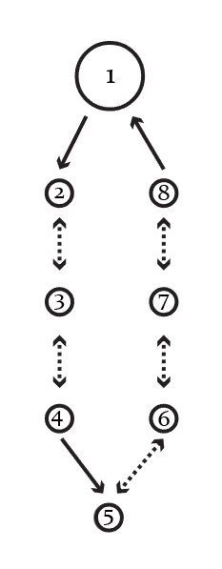A bubble diagram from our example level. Note: the numbers in the diagram refer to the list of eight areas from the previous step.

Almost every designer I know makes these a little differently, and that’s okay! The only requirements are that you must be consistent and that the final product must be readable. Part of the point of making bubble diagrams is that they can be used to communicate your ideas to others, so keep that in mind when you create them.

**Note**: See my article on [Views and Vistas](https://gamedevelopment.tutsplus.com/articles/level-design-views-and-vistas--cms-25036) for information about setting up set-pieces and deciding on views. This is a good stage in the process to decide where those go.

## 4. Rough Maps

### Flesh out Each Bubble

Once I've got the Bubble Diagram finished, we know what's going into this level, and we know how each area is connected each other area.

The next step is to run down the list and create a rough design for each bubble. I almost always do this on paper or in Illustrator, because that's how I learned, but I know a number of great designers who do this kind of thing in-engine to get a better sense of the space. Whatever makes you work fastest is best here.

Below, see an example of what one of the bubbles (specifically *Bubble 3: Tight Corridors*) looks like after I've designed it out on paper (top-down):

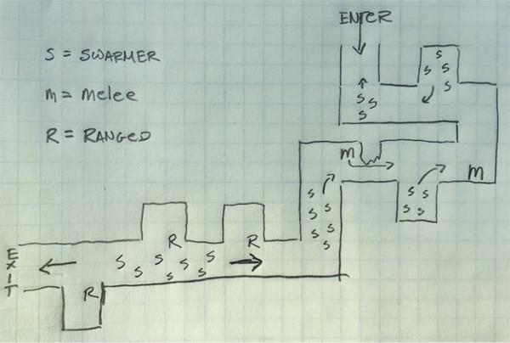

The player starts at the top of this area and proceeds to the bottom. This area makes use of right angles to introduce enemies as a surprise to the player

I'll break this down:

1. Player comes south and fights 3 Swarmers. After player rounds the corner, four more Swarmers run out from an alcove.
2. After rounding the second corner, the player is face-to-face with a Melee enemy. This enemy will need to close distance before attacking, so having it around the corner isn't cheap.
3. Rounding the third corner, the player fights a horde of Swarmers, along with a single Melee enemy that runs from behind cover to attack. The Swarmers come from inside the alcove close to the player, and from around the next corner.
4. The player passes the fourth corner and turns the fifth corner to be confronted by three Ranged enemies, each using the wall as cover, while five Swarmers run at the player.
5. Rounding the last corner, the player proceeds to the area in Bubble 4.

Note how this area is designed in isolation from the others, and scale is considered, but not called out. Note how the distances and heights are still not well defined.

In this rough stage, it's really helpful to be able to change things quickly, so I don't finalize those details until I'm ready to finish the design. I do try to keep the scale relatively consistent between all the areas, though, as this will make my job easier in the next step when we connect the areas together.

Don't get too hung up on accuracy or small details. Things about this design will change constantly from now until the game ships (even after we "finalize" the design). Nothing is being set in stone

### Connect the Areas Together

After taking each bubble and designing them in rough, on paper, I link them together (roughly). For readability, I've done it here in Adobe Illustrator, but this can be done on paper as well.

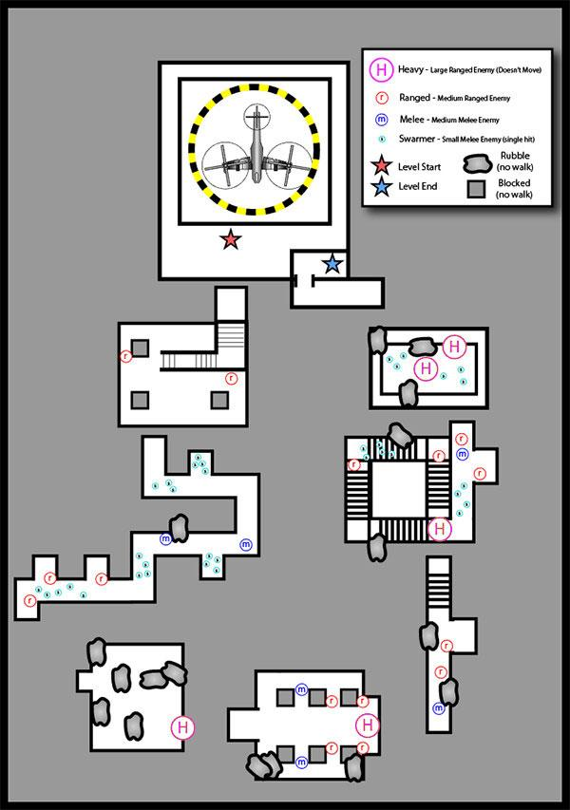

Note how the areas are all laid out end to end, so I know how they'll connect, but I haven't finalized anything yet.

Try to [ramp the intensity up](http://www.chaoticstupid.com/trinity-6-intensity-ramps/), area by area. Make sure you're [combining your enemy types](http://www.chaoticstupid.com/trinity-5-setups/) well, and that in general the difficulty, complexity, and intensity of your enemy encounters or puzzles [increases over the course of the level](http://www.chaoticstupid.com/trinity-7-ramps-part-2/).

Make sure to add plenty of rest spots between combats or challenges to lower intensity from time to time. If you keep the intensity at 10 all the time, 10 will become the new 5.

The end product (as appears in the image above) is what I call a *rough map*.

## 5. Finishing the Design

This step is when I finalize how all the areas connect to each other in physical space. All of the transitions are completed, and I've finalized the heights and distances of everything.

Different designers do this step in different ways. A lot of designers like to dive straight into the engine and build this stuff out, which is great. My preference is usually to finish the 2D map, since I tend to be a bit slower than most when constructing levels in-engine and this speeds me up. The best way will be whatever makes you work faster and makes your end product better.

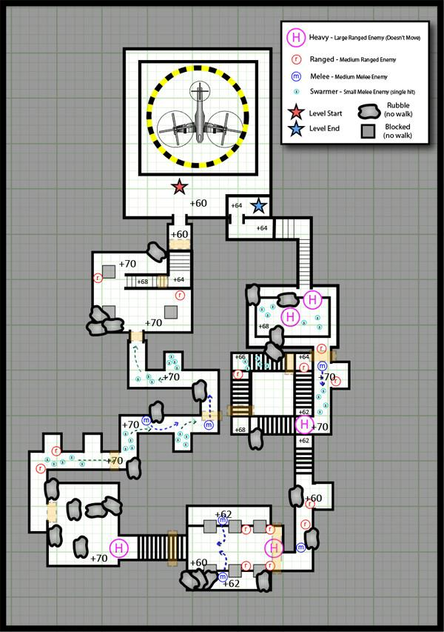The final level map. ([Full-sized PDF version available here](https://cms-assets.tutsplus.com/uploads/users/1159/posts/25662/attachment/FinalTutorialMap.pdf).)

**Notes:**

See [the PDF attached to this tutorial](https://cms-assets.tutsplus.com/uploads/users/1159/posts/25662/attachment/FinalTutorialMap.pdf?_ga=2.62821932.1414089845.1611687056-1177769635.1610559567) if you'd like to zoom in and see details of the final map. You can also see how it's organized (different parts in different layers) to get an idea of how I construct these.

The orange boxes are triggers. Enemies in a room won't attack players until players cross the trigger.

Each box on the grid is 2x2 game units. By doing this map top-down on a grid like this, and by marking heights with numbers (e.g. +70 in the map above), I can give indications in all three dimensions about where things should go.

## Conclusion

Keep in mind that everything we've done so far is only a design. The minute you get it into the engine and start playing with it, you'll find a ton of things you'll want to improve—but having a solid foundation before going into the tools has helped me a lot over the years.

It's my hope that this description of my method has been useful to you. Most people won't want to work exactly this way, and that's good -- just pick out the parts that make you faster, or which make your resulting work more cohesive, and use those.

### Review

I begin the process by understanding all the constraints and restrictions that surround the level. Having a solid handle on my requirements prevents the need for re-work to fix the lack later.

Next, I brainstorm ideas and get together a rough structure for what the level will be like: how many areas I'll need, and what will basically be in them. This usually ends up being a simple numbered list, especially for linear levels like the one we've been working on in this article.

Then, I create a Bubble Diagram so that I can understand how all my areas fit together. It gives me a foundation for understanding the basic flow of my new level at a glance.

After that, I create a rough map. I usually design each area separately, on paper, and then later figure out how to string them together. Once I've got them where I want them, I can see if any changes need to be made to anything I've designed to accommodate the areas fitting together.

Once I've got a rough map, I either start working in-engine or finish the map. When I'm working on my own projects, I go in-engine. When I'm working for others, I usually make a map. A map is a very effective communication tool, and if you keep it relatively up to date it can be useful for people to look at during meetings.

# How to Write a Game Design Document[6]

## Some clarifications before diving in

*When we first shared this post (a few months ago in Reddit), some really constructive and passionate discussions emerged (and we all became better Game Designers because of it).*

There were a few points that kept showing up the most and I'd like to clarify some stuff that will make sense once you've been able to read the whole thing:

1. ***Using a GDD is a thing of the past.***
2. ***When you write a GDD you need to jump right into describing the Game Mechanics.***

I'll probably write a full post discussing each topic in the future, but for now:

**1.-** Like every other industry, the game industry evolves, and the techniques that are used one day quickly become a thing of the past. Specially on a young industry that is still developing it's processes, metrics, etc.... ***Whatever you like to call it*** (GDD, Wiki, Board,...), ***the important thing is to have something that describes your game project*** (or any other project for that matter) ***before jumping into production***.

Here at Trick we name them GDDs and we also use boards (Trello) for managing tasks, and try to divide our project in two week milestones (somewhat resembling Scrum).

We don't use a monolithic GDD that evolves during development, but rather a document that can be used by the team to get up to speed. Then, a few corrections are made to reflect the feedback or ideas of the team during the Game Design phase.

Once production has started, we no longer update the GDD, all new ideas go straight into the board, some of them prioritized (Priority 1 to 3, being 1 a Must do, 2 a Will do, and 3 a nice to have) and some of them into an "Ideas" column to be evaluated at a later time.

In summary, whether you use a GDD or something else, we recommend Game Designers that are just starting to *please, please, please*, consider writing down your ideas into some type of document that other people can read and understand.

**2.-**I think the answer to this is one is that **"It depends",** which should have been made clear in the post. If your game is something like Tetris or Space Invaders or Asteroids...  in other words, games where the Story is practically non-existent and they won't have any effect on the game mechanics, I agree it's the right thing to jump right into Chapter 4 of the template.

For a game like the one we used in this example, it felt natural to describe the characters, what they could do and why, in order to give some context. (*The Gnumies* can merge, which translates into a certain game mechanic, and they are fighting *German the Germ*, which explains the game enemies).

Ultimately, it all depends on your game and your Game Design style. Just take into account that there is an Intro section where you can briefly describe (in one or two paragraphs) the overall mechanics, and the intention is that whoever reads the document can immediately understand your game's genre and high level mechanics, regardless of if you jump straight into a full fledged description or take a detour explaining some backstory first.

## So, how do I go around documenting what I want to do with my game?

That was the first question that came up when I had the great idea that would make me rich (JK of course, I'm still poor). At that point, I didn't even know that I wanted to write a Game Design, and for that I needed to create a Game Design Document (GDD for short).

Doing some research I came across the term, but couldn't seem to find an industry standard or template to help me get started.

After going through a few Game Design books (I highly recommend Jesse Schell's Book of Lenses), and reading all I could online, it was time to create my first GDD. Through the years and iterations it has evolved into the following template, which we use every time we start a new game here at Trick.

Here's a description of each section in the GDD (you can download the template in *.doc format here => [Trick's GDD Template](http://trickgs.com/blog/wp-content/uploads/2016/01/Tricks-GDD-Template-1.docx))

## Project Description

A summary of what this game is about, without going into much detail about game mechanics or anything else. After reading the Project Description, it should be clear what type of game you are trying to make (Social, Casual, Hardcore, etc.) and the genre (Puzzle, RPG, FPS, etc.). Of course, you can add more information that feels relevant to your game.

This section would ideally be one or two paragraphs long. No more than a page for sure.

*For example:*

*This game design document describes the details for a*

*multi-platform touch based 2D puzzle game with novel*

*mechanics and an original story and characters.*

*The game plays like other match-3 games but introduces*

*some innovations.*

*The name is to be defined but candidates are…*

## 1. Characters

The reason we start with characters is because you need to introduce them before the Story. If your game doesn’t have Characters and/or Story, you can just jump to the Gameplay section and remove Sections 1 to 3 (or leave them empty).

*An example of character descriptions:*

***Gnumies*** *are the main characters*

*in this game. These creatures are happy and wealthy, but not*

*greedy. They are wealthy because their ancestry is related*

*to money, or Numismatic, thus their name: Gnumies.*

*They’re hairy and come in a variety of colors.*

***Red Gnumies*** *are passionate and break stuff.* ***Yellow Gnumies***

*are electric and jump up and down.* ***Green Gnumies***

*are tranquil, relaxed and easy going.* ***Blue Gnumies***

*are a little sad and grumpy.*

*Gnumies also have a lot of arms, anywhere from 1 up to 4, and*

*their arms have hands. They have a firm handshake and can*

*combine when holding hands. Gnumies like rough play and*

*leave everything messy…*

You can also add some character artwork here.

## 2. Story

*“An important part of the art of storytelling is to create characters that the guests can empathize with easily, for the more the guests can empathize with the characters, the more interesting the events become that happen to those characters.” –* **Jesse Schell, Book of Lenses**

Having introduced the characters, it’s a good time to talk about the events that will happen throughout the game.

*For example:*

*Gnumies are happily playing inside their castle and causing*

*mischief. The Butler is going insane, but everybody is enjoying.*

*Joker makes jokes.*

*German is home watching TV and his mother bothers him. So he*

*goes out to spy on the Gnumies. Outside it's raining and German*

*is looking envious through the window, getting all wet.*

*A strange mysterious person-something gives him a key that he*

*can use to enter through a backdoor. He goes in with his army,*

*kidnaps and jails female and baby Gnumies, and kicks everybody*

*else out of the island…*

## 2.1. Theme

*“Resonant themes elevate your work from craft to art. An artist is someone who takes you where you could never go alone, and theme is the vehicle for getting there.” -* **Jesse Schell, Book of Lenses**

This is important for when other people read your design. Overall, the theme speaks about what kind of story you want to tell: is it comedy, is it the real life or is it just fantasyyy... :)

*For example:*

*This is a game about sadness and hardships. There is*

*action and happy moments but between each chapter*

*the story must progress in a way that clearly states that*

*the Gnumies are sad because they lost their home.*

*It must also have a sense of humor and be funny.*

You can skip this section if you think it’s irrelevant for your game.

## 3. Story Progression

So, you have a Story, but how will the game take your players through that story.

*“The world of your game is a thing that exists apart. Your game is a doorway to this magic place that exists only in the imagination of your players” –* **Jesse Schell, Book of Lenses**

*For example:*

*The game starts with a short intro scene where the Gnumies*

*are getting kicked out of their homes. Then they land in an*

*island and the first chapter begins.*

*The first chapter is the Tutorial. This can be skipped. Here*

*the levels are few and the Butler introduces the user to*

*the mechanics.*

*Once the player beats the tutorial he can advance into the*

*First World* ***Forest World.***

*When the player beats the Forest World, he gets the First Key*

*and then can choose to open the* ***Volcano World*** *or*

***Icy Mountain World.*** *Once he defeats one of these worlds….*

*It’s very important to develop the world like a place were*

*not only this story, but multiple stories could be happening*

*at the same time. This opens the door for sequels and*

*merchandise.*

## 4. Gameplay

“*The game begins with an idea.” -* **Jesse Schell, Book of Lenses**

This is (probably in 99% of games) the most important section of the GDD. It’s where you describe what your Gameplay (yes, with capital G), will be like.

Since this section can become humongous, we went ahead and divided it in sub-sections that made sense to us. Of course, this is a very subjective topic and what works for us may not work for you.

## 4.1.    Goals

In short, why is the player playing your game? It’s good to add this information to a separate section so you don’t have to guess while reading through the whole GDD.

*For example:*

*Overall (long term): Help Gnumies return home*

*Gameplay (short term): Defeat the enemies,*

*advance to the next level, etc…*

## 4.2.    User Skills

This is not the most intuitive section, but it really helps to narrow down your scope if you think about what are the skills your player needs to master in order to play your game. Believe us, writing this list will help you find problems in your Game Design. For example, you may be trying to develop a game for kids but realize you require them to do something that is too advanced for their age, or some inputs may be good for Mobile but not for a Console with a Joystick. Also, if your game is going to have Custom HW built around it, then this list will allow you to figure out what components you’ll need to make it work.

*For example:*

* *Tap on the screen*
* *Drag and drop*
* *Memory*
* *Puzzle solving*
* *Rearranging pieces*
* *Manage resources*
* *Strategize*

## 4.3.    Game Mechanics

This is where you describe your proper game mechanics. Spare no words, when you circulate this GDD around your team, there has to be the least reasonable amount of doubt about what the gameplay should be like. This is a very good section to add some Artwork or Screenshots of your prototype (we prefer to prototype the mechanics and figure out if they are fun before committing resources to a game).

There are complete books and sites with materials about how to describe game mechanics, so we’ll not elaborate with examples here. Linked resources at the bottom.

## 4.4.    Items and power-ups

We use this section to elaborate on the Game Mechanics. In order to avoid having a single section with everything in our brains poured into it, we use the section above to describe the core mechanics, and this section to talk about things that can be added to the game in order to improve the fun and empower the player.

So, if your game is a match-3 game, then in the previous section you’d go and describe exactly how a match-3 game would work (and adding your variations to the formula).

In this section you’d add every power up and item the player can use/encounter/buy and how they would affect the core gameplay.

*For example:*

*When finishing a world, you could get a power up*

*related to that world. For example, finishing the*

*volcano world, can give you an item that makes*

*red Gnumies more powerful. It could be a scarf,*

*or something they can wear, and those items could be*

*seen in-game later. You can level up items using*

*in-game currency, or use real money to acquire*

*in-game currency packs….*

## 4.5.    Progression and challenge

This is also a very subjective section that may or may not work in your design. Our idea behind this section is to elaborate on how the difficulty will increase throughout the game, and making sure we give the player the tools to catch up to it.

*For example:*

*Difficulty will advance by making the enemies harder.*

*To mitigate difficulty, the user will have to play better,*

*level up Gnumies and use items (also level up the items).*

Also, here we can talk about the way players will unlock new levels or missions.

*For example:*

*Each boss drops a key with a jewel of that world’s color.*

*Worlds can be tackled in any order. When the user beats*

*every world and has every key, then he can go and work*

*his way through the last world. The order in which a user*

*tackles each world can be chosen by him. The boss at the*

*end of a world drops a key that can be used to open a*

*different world. Once the item is used, it is lost forever.*

*That way, the user must complete the world he selected*

*before opening the next. At that point the difficulty for*

*that world is set*

## 4.6.    Losing

Yes, losing! What are the losing conditions? Time, health, all of them? This is the section where you describe how the player gets to see your "Game Over" screen.

*For example:*

*These are the losing conditions: losing by running out*

*of time, losing by running out of moves, losing when*

*there are no available combinations.*

*When the player loses, there must be an image showing*

*the Gnumies wounded/scratched. Maybe they can lose*

*some hair and you can see the skin under the hair.*

## 5. Art Style

This section is self-explanatory: here’s where you describe your ideas about what the game should look like. Since a picture is worth a thousand words, this is a great place to add some concept art.

*For example:*

*This is a 2D isometric game, with high quality 2D sprites.*

*The character design should resemble that of Studio Ghibli.*

*Everything should be very colorful and feel alive, with*

*highly animated scenarios and layered backgrounds….*

## 6. Music and Sounds

*“Music is the language of the soul, and as such, it speaks to players on a deep level.” –* **Jesse Schell, Book of Lenses**

Here is where you describe your Music and Sound FX. Depending on how important this is in your game, then you can split this section in different sub-sections.

*For example:*

*The music should have a Retro style, appealing to 8 bit*

*nostalgia but high quality.*

*It’s important that a lot of sound effects praise the user*

*when he does something good. There should be immediate*

*and positive feedback.*

*When time is running low, add a sound that makes the*

*user nervous.*

*The sad scenes should be accompanied by Accordion/Violin*

*music and sound like a sorrowful Tango.*

*For In-Game music, use a more relaxed approach with*

*happy tunes and going up on tempo as the level progresses.*

*When in caves the music should sound muffled.*

## 7. Technical Description

Here’s where you describe the platforms you’d be launching for and tools you’ll be using or are considering to use throughout your development. This should not be a detailed technical description, for that you have the Technical Design Document (TDD). Here we are just scratching the surface.

*Example:*

*Initially, the game will be Mobile Cross-platform:*

*• iOS*

*• Android*

*• Windows Phone*

*Follow with PC standalone version and Facebook Canvas.*

*Could add Mac and/or console support (through e-stores)*

*in a future.*

*Consider the following engines: Marmalade, Unity 3D,*

*Unreal Engine 4.*

*For project management use JIRA. Use Perforce for*

*storing code and assets.*

*TBD properly in Technical Design Document.*

## 8. Marketing & Funding

A completely optional section, but write your ideas now so you don’t forget them later. It’s important to think about how you are going to market your game, even before starting your development. It’s also important to know where the money to make the game is coming from.

*“A plan is a real thing.” –* ***Jesse Schell, Book of Lenses***

*For example:*

*Prototype the first level, and launch a Kickstarter campaign*

*where we show that level.*

*Try to land a publishing deal.*

*Is there any Government funding we can apply to?*

*Create a press kit and send to gaming news websites.*

*Start a YouTube Channel and post development diary*

*videos.*

*Etc.…*

## 8.1.    Demographics

It’s important to know who you’ll be targeting, this should spill into the game design. If you are targeting 15 to 25 year old males, then your main character probably shouldn’t be a pink pony (not that there’s anything wrong with that).

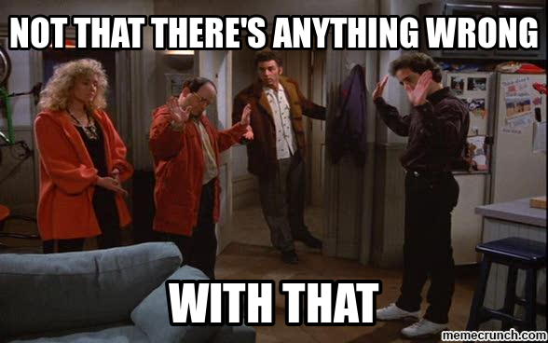

Not that there's anything wrong with that

*Example:*

*Age: 12 to 50*

*Sex: Everyone*

*Casual players mostly*

## 8.2.    Platforms & Monetization

You can add a little more detail about how you are going to approach the release on each platform.

*For example:*

*Initially: Free android app with in-game ads, and paid*

*version without ads.*

*Free iOS with ads. Paid iOS version without ads.*

*In game purchases.*

*Consider: Windows 8, Windows Phone 8, XBOX live*

*and Nintendo e-shop.*

## 8.3.    Localization

Your supported languages. Just add whatever you have in mind, this is something that probably won’t be a priority until later.

*Example:*

*Initially English/Spanish.*

*Later update with: Italian, French, German, etc.*

*Consider getting an Asian publisher for expanding*

*to Asia, someone that can help with localization.*

## 9. Other Ideas

Another completely optional section. If you have ideas that you are not sure if they should go in the game or not, just add them here so you don’t forget them.

*For example:*

* + *Level designer*
  + *Be able to rate levels created by other users*
  + *Achievements*
  + *Leaderboards*
  + *Should the game have a Multiplayer mode?*

*“Generally, it is safe to assume that a multiplayer online game will take four times the effort and expense to create compared to a similar single-player game.”*

*“There is an old rule of thumb that it takes six months to balance your game after you have a completely working version” –* **Jesse Schell, Book of Lenses**

## Closing comments

We hope other game developers can find this template useful. Looking forward to starting the conversation about how this document can be changed or improved.

Here's are some Gnumies, please take them!

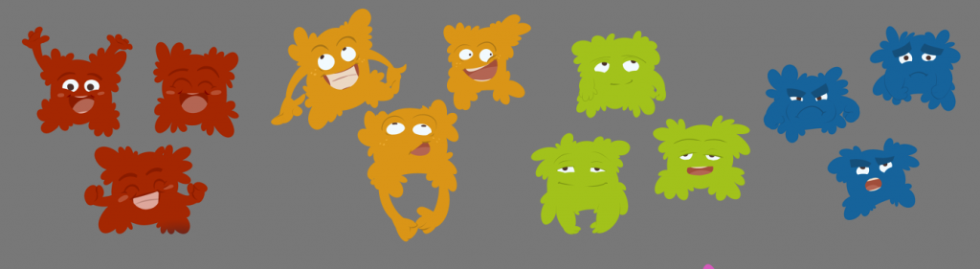

1. <https://www.cgspectrum.com/blog/game-design-basics-how-to-start-building-video-games>
2. <https://www.studytonight.com/3d-game-engineering-with-unity/genres-of-game>
3. <https://gamedevacademy.org/best-game-engines/>
4. <https://gamedevacademy.org/game-design-tutorial/>
5. <https://gamedevelopment.tutsplus.com/tutorials/a-beginners-guide-to-designing-video-game-levels--cms-25662>
6. <https://www.gamasutra.com/blogs/LeandroGonzalez/20160726/277928/How_to_Write_a_Game_Design_Document.php>